**FitTipz System Design Document**

I. **Introduction** -

This document is for our app FitTipz. The document includes several diagrams and charts that illustrate the inner workings of FitTipz. Firstly, there is the design-level class diagram. This is used to demonstrate the relationship between classes and the methods that can be found within them. The primary purpose of this is to provide a clear and concise visual representation of the system's structure. This can be used to provide stakeholders with a clearer picture of how the app will function. For example, it illustrates the relationship between the AdvancedSearch class and its child class, TipzTips. Second, are the first cut domain sequence diagrams. These are used to show the interactions between our system and its various objects. This will be helpful during the programming stage because it gives a visual representation of interactions. It helps illustrate the proper sequence of events as well as their timing. Finally, there are the statecharts. They represent the change of states by showing both the method that causes the change and the resulting new state. Its usefulness stems from the fact that developers can see all possible states the given object can be in. Similar to our login chart, which illustrates the various states the FitTipz account object can be in.

II. **Design-Level Class Diagrams**.

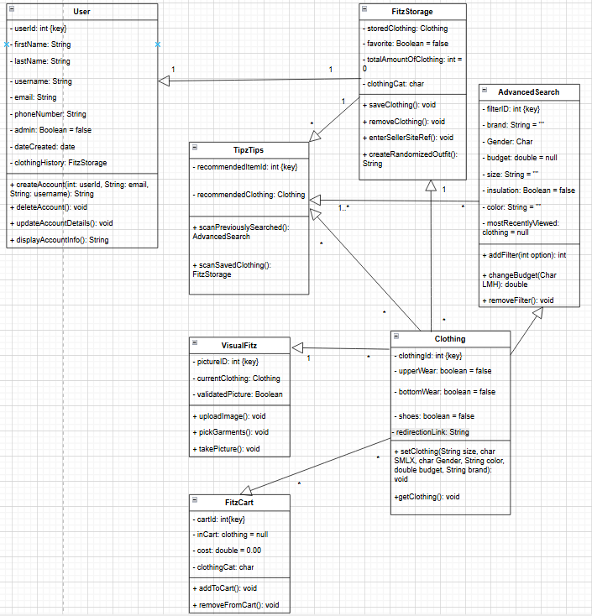

III. **Statechart Diagrams**:

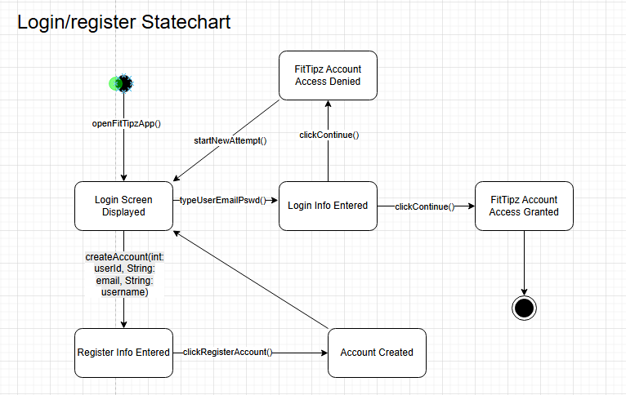

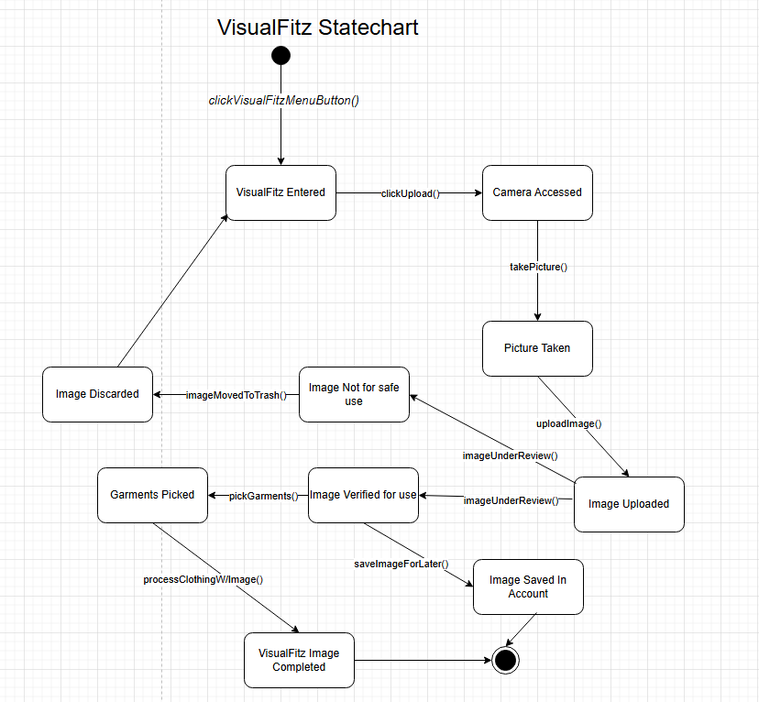

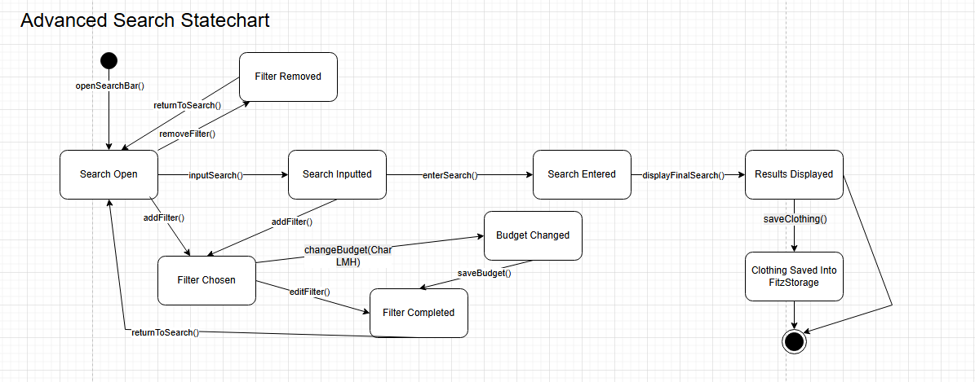

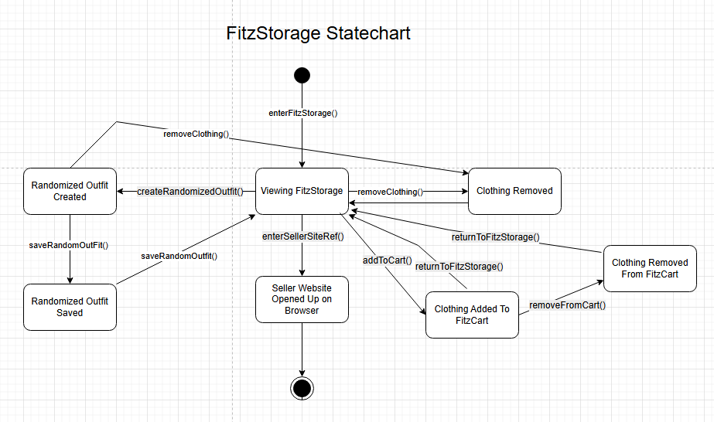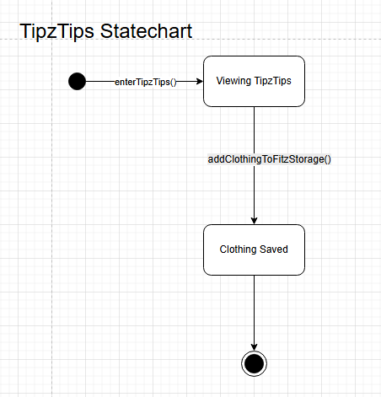

IV. **First Cut Domain Sequence Diagram** 